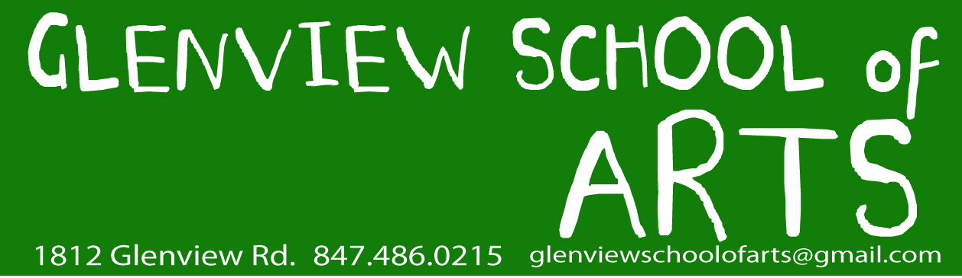

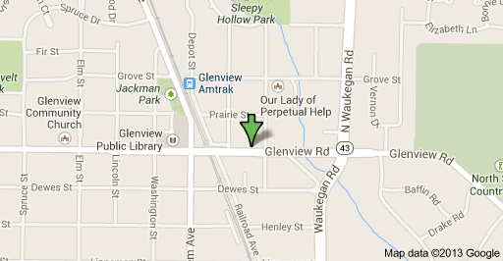

847.208.6165 www.glenviewschoolofarts.com
glenviewschoolofarts@gmail.com
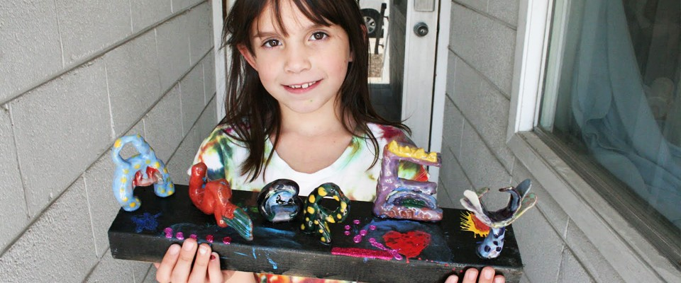

TABLE OF CONTENTS

Mission, Goals and History ...…………………...................................................... 3
Philosophy and Objectives ............................................................................ 4
Course Descriptions .......................................................................................5
Admissions Requirements and Academic Calendar.......................................10
Certification Requirements, Grading, Transcripts and Attendance...............11
Tuition, Fees and Refund Policy, Tuition Refund Chart, Withdrawal from Class
and Dismissal ...............................................................................................13
Grievance, Complaint Policy, and Procedure ………………………………….….………14
State/ Federal Certifications.......................................................................... 15
Consumer Information ...………………………………………………………………………….….…..….16
Institutional Disclosures Reporting Table...………………………………................... 17

* The Glenview School of Arts is not accredited at this time.

Glenview School of Arts is established in Chicago. We have been part of the community for seventeen years. Although our Teacher Training Program is new, we are well connected to art and education institutions all throughout the Chicago region.

Mission:
The Teacher Training Program at The Glenview School of Arts is designed to offer future art teachers a comprehensive understanding of K -12 art education. We believe in the importance of traditional art education that emphasizes the need for the careful, detailed creation of artwork and naturalistic representation. We work closely with students to prepare them for their careers as art teachers. Classroom experience as instructors is part of the program. Students under our training will be instructed in the preparation of individual lesson plans: Learning to Teach Art (K-12th grade) and Portfolio Development (9th-12th grade). The Glenview School of Arts is currently working with domestic and international candidates who are interested in becoming art teachers. They will have access to professional networks of art educators and artists where English is the primary language. This will give practicing artists additional opportunities to develop their pedagogical skills by participating in the world of art education.
Goals:
1. To enhance employment opportunities in after-school programs, art centers, small local art schools, social service art programs, as well as art businesses of their own. The latter would include art therapy practices and the introduction of art programs in assisted-living centers and nursing homes.
2. To increase opportunities for students to pursue degrees in higher education, especially in colleges and universities accepting Prior Learning Credits based on courses and work experience. Advanced degrees will further increase employment opportunities.
3. To promote networking connections through art educational events, seminars, and workshops.
4. To greatly increase employment opportunities for those who want to teach in areas where proficiency in English is essential to obtaining most levels of employment or education.
5. To prepare students to be able to teach art in English anywhere when required.
History:
The Glenview School of Arts Teacher Training Program is new and is based on requests from people who want to become good art teachers in the U.S. and abroad. Over the past nineteen years, the Glenview School of Arts has created many constructive experiences with students (K-5G, 6-8G), building their skills and developing portfolios. Many of our students have been accepted into major art colleges and universities, such as the Rhode Island School of Design, the Pratt Institute, and Parsons School of Design in New York. Most of our students have won full and partial scholarships, have entered graduate programs, and are successfully employed in their fields. The Glenview School of Arts, licensed by the City of Glenview, offers art programs such as K-12 drawing and painting, and an art portfolio development program for advanced placement art students in high school. Our program also helps students pursuing professional careers in art and adult education. With visual language, we’ve been able to build a unique teacher training curriculum over a period of several years. The Glenview School of Arts has had a permit from the Illinois Board of High Education since 2015 to offer this program.
Please see our website for further information: www.glenviewschoolofarts.com
Philosophy:

The Glenview School of Arts believes that art is a basic form of human communication, a universal language flowing through all ages and cultures. We believe that America, as a truly multi-cultural nation, is the ideal place for promoting multi-cultural teaching directions. Additionally, research proves that art enhances the ability to succeed academically. We believe teachers should have the ability to promote a cross- curricular perspective, open mindedness and appreciation of art from an early age.
“What nobler employment, or more valuable to the state,
than that of the man who instructs the rising generation.” - Marcus Cicero

Objectives:
Students will increase their English proficiency, their art-related vocabulary, use of idioms, expression of concepts, and reading and comprehension skills. Research and sources for teaching college prep courses and providing career guidance are also available.
2. Students will become familiar with all studio products and processes necessary for the teaching of art.
3. Students learning to teach K-12 will achieve an understanding of art history, art criticism, aesthetics and will be able to teach these subjects to others, as well as apply it to their own artwork.
4. Students will learn how to instruct and guide those who choose a career in art; both in 2D and 3D art.
5. Students will be familiar with all current educational practices.
6. Students will continue to build their own portfolios in order to apply for jobs.
7. Students will acquire a multi-cultural perspective.
8. Students will improve their communication skills.
9. Students will gain a better understanding of the American educational system.
10. Students will increase their creativity and problem-solving ability.

Course Descriptions
1. Learning to Teach Art: 3 sessions – one-year program (1,350hrs)

 | Fall Session | Spring Session | Summer Session
Course Start & End | 8.28.2023-  12.16.2023 | 1.8.2024 - 4.27.2024 | 5.13.2024-  8.3.2024
Duration | 16 weeks  450hrs | 16 weeks  450hrs | 12 weeks  450hrs

This class provides a comprehensive overview of general art information appropriate to grades K-12. The Learning to Teach Art course will include: foundational skills in drawing and painting, concept development, an explanation of the value of art education, art education, art history, aesthetics and art criticism, studio time, understanding how to handle all different kind of mediums, and student teaching.

Prerequisites;
-High school diploma or equivalent degree
-Passing grade on Glenview School of Arts English Skills Entrance Exam or completion of Bridge to English Fluency

Objectives;
1. Students will become familiar with all current art educational practices, theories, and resources.
2. Students will become familiar with all studio products and processes necessary for the teaching of art.
3. Students will achieve a stronger understanding of art history, art criticism and aesthetics from the perspective of teaching.
4. Students will enhance their English proficiency, especially with art-related vocabulary, idioms, concepts, reading, and research and will understand sources of career guidance.

2. Learning to Teach Art Portfolio Development: 3 sessions – one-year program (1,800hrs)

 | Fall Session | Spring Session | Summer Session
Course Start & End | 8.28.2023-  12.16.2023 | 1.8.2024 - 4.27.2024 | 5.13.2024-  8.3.2024
Duration | 16 weeks  450hrs | 16 weeks  540hrs | 12 weeks  540hrs

Students will learn to teach Art Portfolio Development to high school art students, college students who want to study art, and job-seeking adults, using only English. This class is designed to help students teach high school students how to prepare high quality art portfolios, which are required to gain admission into colleges and universities. This class will provide a comprehensive overview of all areas necessary for teaching Art Portfolio Development: foundational skills in drawing and painting, concept development, exposure to various artistic media and techniques, instructional presentation, including critique sessions and exhibitions. Finally, students will learn how to teach high school students about the preparation of college-entry materials, including home exams and other specific requirements.

Prerequisites;
-High School diploma or equivalent degree
-A passing grade on the Glenview School of Arts English Skills Entrance Exam or completion of Bridge to English Fluency course.
-Students who completed the Learn to Teach Art course or students with a portfolio of 20 artworks which meet the standards of the Glenview School of Arts.

Objectives;
1. Students will enhance their English proficiency, especially with art -related vocabulary, idioms, concepts, reading skills, research and sources for career guidance.
2. Students will learn how to instruct and guide others who wish to pursue a professional career in art.
3. Students will guide professional artists seeking employment on how to build a strong resume and portfolio.
4. Students will learn basic concepts of art history, aesthetics and art criticism from the perspective of portfolio development.
5. Students will learn to conduct peer portfolios reviews including group and individual critiques.
3. Bridge to English Fluency: 2 sessions /240hrs each – Six month program (480hrs) (Students pick 2 quarters)

 | 1st Q | 2nd Q | 1st Q | 2nd Q
Course Start & End | 7.10.2023 -9.29.2023 | 10.2.2023 -  12.22.2023 | 1.8.2024-  3.29.2024 | 4.1.2024 - 6.21.2024
Duration | 12 weeks  240hrs | 12 weeks  240hrs | 12 weeks  240hrs | 12 weeks  240hrs

Prerequisite;
-High School diploma or equivalent degree

Objectives;

1. To enhance English proficiency through listening, reading, writing, and speaking.
2. Assessment and placement in appropriate classes.
3. Consistent practice of English in all classroom levels of learning.
4. Passing grade on Glenview School of Arts entrance exam.

Admission Requirements:
Prospective applicants must fill out an online application form at www.glenviewschoolofarts.com. This can be found on the Other Programs tab in the upper-left-hand side of the school’s website. Applicants must have a high school degree or equivalent degree such as a GED, and must be at least 17 years of age or older.
All applicants must also pass our entrance exam, which assesses English proficiency. The exam covers grammar, reading comprehension, and writing skills. If a student does not pass the entrance exam, the School offers an ESL course that will prepare students for it.

Academic Calendar (2022-23): The school will be closed on the following holidays:

Labor Day: September 5, 2022
Thanksgiving Day: November 21 - November 26, 2022
Fall Break: September 19 - Oct 1, 20202
Winter Break: December 19 - Jan 7, 2023
Spring Break: March 20- April 8, 2023
Summer Break: Jun 10 –July 10, 2023

Enrollment Deadline (TBD)
 | Fall Session | Spring Session | Summer Session
Application Deadline | 8.14.2023 | 12.21.2023 | 4.29.2024
Registration Deadline | 9.11.2023 | 1.22.2024 | 5.27.2024
Start of Class | 8.28.2023 | 1.8.2024 | 5.13.2024
End of Class | 12.16.2023 | 4.27.2024 | 8.3.2024

 | 1st Q | 2nd Q | 3rd Q | 4th Q
Application Deadline | 7. 8.2022 | 9.28.2022 | 1. 4.2023 | 4. 5.2023
Registration Deadline | 7.20.2022 | 10.14.2022 | 1.18.2023 | 4.19.2023
Start Day of Class | 7.11.2022 | 10.03.2022 | 1. 9.2023 | 4.10.2023
End of class | 9.17.2022 | 12.17.2022 | 3.18.2023 | 6.17.2023

Certification Requirements:
Certificate of Completion will be awarded by the Glenview School of Arts for each course completed.
(1) 1 year- 3 sessions courses, for a total of 1,350 hours of Learning to Teach Art
(2) 1 year- 3 sessions courses, for a total of 1,800 hours of Learning to Teach Art Portfolio Development
(3) 6 month – 2 sessions of 12-week courses for a total of 480 hours of Bridge to English Fluency.

Grading;
1. All courses will be graded on a pass/fail basis.
2. Students will not receive credit for classes they have failed, and will be required to retake classes in order to receive a Certificate of Completion.

Transcript Request;
Student may request a transcript after a course completion. Students must fill out the transcript request form available at the Glenview School of Arts.
There is a $7 charge for each transcript copy.

Attendance;
Students are expected to be in class on time. Students who are not punctual will be counted tardy. If a student is tardy three times, it will count as one absence. Three absences will result in an automatic F. In the event of a fail, the student must retake the course.
If a student is ill, a doctor’s note will be required to excuse an absence. In cases of family emergencies, the instructor should be contacted prior to class.

Tuition:
 | Learning to Teach Art | Learning to Teach Art Portfolio Development | Bridge to English  Fluency
Tuition | $10,500.00/yr | $12,500.00/yr | $3,580.00/6 months
Materials Fee | $250.00 | $200.00
Textbooks | $300.00 | $300.00 | $300.00

Fees: Tuition must be paid in full by the first day of each term.
Course Registration Fees………...................$90.00
Late Registration Fees…………………….........$100.00

Payments in monthly installments are accepted by setting arrangements with the director.
Checks, money orders and credit cards are acceptable forms of payment.
Tuition covers use of all computer equipment necessary to participate in the courses.
The Glenview School of Arts allows students to withdraw from courses with tuition charges being reduced according to the following tuition refund policy.

Refund Policy:
The Glenview School of Arts reserves the right to cancel any class if enrollment is fewer than two students. All tuition will be refunded.
The refund policy will follow the deduction schedule below. A dated written request must be submitted to the director.
Registration fees, and textbooks and course materials fees are non-refundable.

Tuition Refund Chart:
Week of Withdrawal | School Refund Policy
Before start of class | 100%
1st week | 90%
2nd week | 75%
3rd week | 25%
4th week | 10%
5th week | 0%

Withdrawal from Class and Dismissal;
The Glenview School of Arts reserves the right to dismiss any student whose conduct or attendance does not meet the school’s standards. A student may be dismissed if:
1. The student has been absent for more than five days without notice.
2. The student has been involved in conduct that is disruptive to other students and is a distraction to others.
3. The student is destructive toward school property.
4. If tuition payments are not met.
1095.240: The disclosure shall consist of a statement containing the following information for the most recent 12-month reporting period of July 1 through June 30 (Section 37 of the Act):

Grievance, Complaint Policy and Procedure;
Student complaints should be brought up with the instructor. If the complaint is not resolved, the student should contact the director in writing and the issue will be dealt with on a case-by-case basis. If the complaint is still not resolved, the student should submit a written report to
IBHE or call:

Institutional Complaint Hotline: (217) 557-7359
COMPLAINTS AGAINST THIS SCHOOL MAY BE REGISTERED WITH THE BOARD OF HIGHER EDUCATION".
(Section 37 of the Act) (See Section 1095.250.)

Website https://complaints.ibhe.org/

Illinois Board of Higher Education:
1 North Old State Capital Plaza,
Suite 333
Springfield, IL 62701

State/ Federal Certification:

The Glenview School of Arts is approved by the Division of Private Business and Vocational Schools of the Illinois Board of Higher Education. The Glenview School of Arts is not accredited by the U.S. Department of Education.

Illinois Board of Higher Education:
1 North Old State Capital Plaza,
Suite 333
Springfield, IL 62701

CONSUMER INFORMATION - Disclosure Information:

All schools are required to make available, at a minimum, the following disclosure information clearly and conspicuously on their 1) internet website, 2) school catalog, and, 3) as an addendum to their Enrollment Agreement:

•The number of students who were admitted in the programs as of July 1 of that reporting period.
6 students
•The number of additional students admitted in the programs during the next 12 months and classified in one of the following categories: new starts, re-enrollments, and transfers into the program from other programs at the school.
New Starts: 2 students
Re-Enrollment: 3 students
Transfer: 0 students
•The total number of students admitted in the programs during the 12 months reporting period.
6 students
•The number of students enrolled in the programs during the 12-month reporting period who: transferred out of the program and into another program at the school, completed or graduated from a program, withdrew from the school, and are still enrolled.
Completed: 0 student (Last session student –submitted final projects)
Transferred: 0 students
Withdrawal: 1 students
Still Enrolled: 5 students

•The number of students enrolled in the program who will be: placed in their field of study, placed in a related field, placed out of the field, not available for placement due to personal reasons, and not employed.
Placed in their Field of Study: 0 student
Placed in a related field: 0 student
Placed out of the field: 0 students
Not available for placement due to personal reasons: 0 students
Not employed: students who are still enrolled in the program
•The number of students who will take a State licensing exam or professional certification exam, if any, during the reporting period, as well as the number who passed:
0 students
•The number of graduates who obtained employment in the field who did not use the school’s placement assistance during the reporting period
0 students
•The average starting salary for all school graduates employed during the reporting period
Part Time: $25,000.00

Institutional Disclosures Reporting Table
Reporting Period: July 1, 2020 - June 30, 2021
Glenview School of Arts |  | Indicate all ways the disclosure information is distributed or made available to students at this institution:
 |  | * | Attached to Enrollment Agreement
 |  | * | Provided in Current Academic Catalog
 |  | * | Reported on School Website
 |  | _______ | Other: __________________________________
Per Section 1095.200 of 23 Ill. Adm. Code 1095:
The following information must be submitted to the Board annually; failure to do so is grounds for immediate revocation of the permit of approval.
DISCLOSURE REPORTING CATEGORY |  | Learning to Teach Art CIP Code: 13.1302 SOC Code: 25-3090 Art Teacher Education | Learning to Teach Art Portfolio Development CIP Code: 13.1302 SOC Code: 25-3090 Art Teacher Education | Learning to Teach Elementary Art: CIP Code : 13.1302/ SOC Code 25-3090 Art Teacher Education | Learning to Teach Middle School Art CIP Code : 13.1302/ SOC Code 25-3090 Art Teacher Education | Bridge to English Fluency CIP Code: 13.1401 SOC CODE: 25-3090 Teaching English as a Second or Foreign Language /ESL Language Instruction
1) The number of students who were admitted in the program or course of instruction* as of July 1 of this reporting period. |  | 3 | 1 | 2 | 0 | 0
2) The number of additional students who were admitted in the program or course of instruction during the next 12 months and classified in one of the following categories:
 | a) New starts | 2 | 1 | 1 | 0 | 0
 | b) Re-enrollments | 1 | 0 | 0 | 0 | 0
 | c) Transfers into the program from other programs at the school | 0 | 0 | 1 | 0 | 0
3) The total number of students admitted in the program or course of instruction during the 12-month reporting period (the number of students reported under subsection A1 plus the total number of students reported under subsection A2). |  | 3 | 1 | 2 | 0 | 0
4) The number of students enrolled in the program or course of instruction during the 12-month reporting period who:
 | a) Transferred out of the program or course and into another program or course at the school | 1 | 0 | 0 | 0 | 0
 | b) Completed or graduated from a program or course of instruction | 2 | 0 | 0 | 1 | 0
 | c) Withdrew from the school | 1 | 2 | 1 | 0 | 0
 | d) Are still enrolled | 3 | 1 | 2 | 0 | 0
5) The number of students enrolled in the program or course of instruction who were:
 | a) Placed in their field of study | 0 | 0 | 0 | 0 | 0
 | b) Placed in a related field | 0 | 0 | 0 | 0 | 0
 | c) Placed out of the field | 0 | 0 | 0 | 0 | 0
 | d) Not available for placement due to personal reasons | 0 | 0 | 0 | 0 | 0
 | e) Not employed | 0 | 0 | 0 | 0 | 0
B1) The number of students who took a State licensing examination or professional certification examination, if any, during the reporting period. |  | 0 | 0 | 0 | 0 | 0
B2) The number of students who took and passed a State licensing examination or professional certification examination, if any, during the reporting period. |  | 0 | 0 | 0 | 0 | 0
C) The number of graduates who obtained employment in the field who did not use the school's placement assistance during the reporting period; such information may be compiled by reasonable efforts of the school to contact graduates by written correspondence. |  | 0 | 0 | 0 | 0 | 0
D) The average starting salary for all school graduates employed during the reporting period; this information may be compiled by reasonable efforts of the school to contact graduates by written correspondence. |  | 25000 | 30,000 | 25000 | 25000 | 0
*A course of instruction is a standalone course that meets for an extended period of time and provides instruction that may or may not be related to a program of study, but is either not part of the sequence or can be taken independent of the full sequence as a stand-alone option. A Course of Instruction may directly prepare students for a certificate or other completion credential or it can stand alone as an optional preparation or, in the case of students requiring catch-up work, a prerequisite for a program. A stand-alone course might lead to a credential to be used toward preparing individuals for a trade, occupation, vocation, profession; or it might improve, enhance or add to skills and abilities related to occupational/career opportunities.
Note: As indicated in the PBVS Administrative Rules, Section 1095.200, student retention and graduation rates must be maintained that are appropriate to standards in the field. Furthermore, a State licensing examination or professional certification examination passage rate of at least 50% of the average passage rate for schools within the industry for any State licensing examination or professional certification examination must be maintained.

 | } In the event that the school fails to meet the minimum standards, that school shall be placed on probation.
 | } If that school's passage rate in its next reporting period does not exceed 50% of the average passage rate of that class of schools as a whole, then the Board shall revoke the school's approval for that program to operate in this State. Such revocation also shall be grounds for reviewing the approval to operate as an institution.
 | Our institution, Glenview School of Arts received approval in April 21, 2015.

